ACTIVITY 5

MUSIC NOTES

DIRECTIONS
Have one group member upload this docx file to your Google Drive and share it with your groupmates and your instructor. Name your document “GroupX_Activity5” (where X is your group number). Work together to type up your responses to each question. Download your document as a PDF and submit this to Canvas individually.

INTRODUCTION
Some people who have a good ear for music can identify the notes they hear when music is played. One way a music teacher can determine if their students have a good ear for music is to give them a note identification test. A note identification test consists of a music teacher choosing one of the seven notes of a C Major scale (A, B, C, D, E, F or G) at random and playing it on the piano. Each time a note is played by the teacher, the student taking the note identification test attempts to identify which of the seven notes the teacher played. To ensure that the student cannot see which notes the teacher plays on the piano, the student is standing in the room facing away from the piano. The entire note identification test consists of 10 notes that the student tries to identify.
This note identification test was given to Jasmine, a young music student, to determine whether or not she has this ability. She was able to correctly identify 7 notes out of the 10 notes that were played. We are interested in answering the following question:
Does Jasmine have an ability to recognize music notes played on a piano?

INTUITIONS
- Based on your personal experience/opinion, do you think that Jasmine is just guessing? Why or why not?

- If it really is the case that Jasmine has no idea how to identify music notes and was just guessing, is it possible that Jasmine could have guessed 7 out of 10 correctly? Would this result be very surprising, somewhat surprising, or not so surprising? Explain your intuitions.

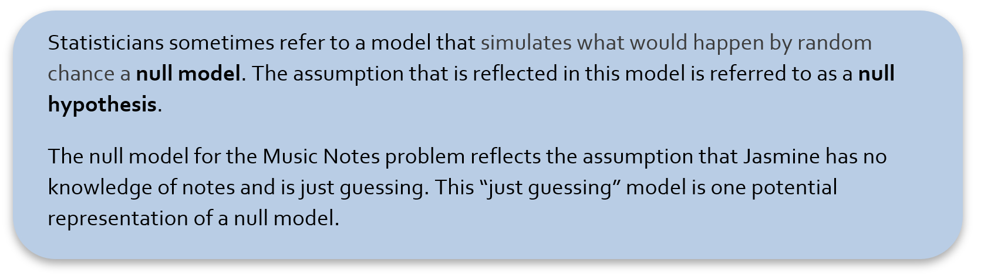

MODELING
- Construct a TinkerPlots sampler to model this note identification test situation that reflects the null hypothesis.
  - Copy and paste a picture of your TinkerPlots sampler below.

  - State what the repeat and draw values are set to and why.

  - Describe how you named the attribute(s) of the device(s) in your sampler and explain why you chose that/those name(s) for the attribute(s). What is being represented by that/those device(s)?

  - State whether you set the device(s) in your sampler to sample with or without replacement and why.

  - Describe how the idea of the null hypothesis is captured by your sampler.

- Using the context of the problem describe what is happening when you click run on your sampler.

GATHERING RESULTS
- Run a single trial of the simulation. Make a plot of a simulated trial that allows you to see the number of times each outcome occurred.
- Copy and paste this plot below.

- Explain what a dot in the plot represents.

- What statistic do we want to collect for each trial in order to provide evidence that can help us determine if the student was guessing or not? Justify your choice.

- Now use TinkerPlots to collect on the statistic you identified in the previous question and create a plot of the results from the 500 trials.
- Copy and paste your plot from the 500 trials below.

- Interpret what a dot in the plot represents.

- In your distribution, what is the probability that 7 or more of the 10 notes were guessed correctly under the null model? What does this suggest about your answer to the research question? Explain.

- Write up a formal conclusion to this hypothesis test in the context of the problem.

We can approximate the probability that the null model will produce results where 14 (or more) infants select the helper toy by computing the proportion of the simulated trials that produced 14 (or more) infants that selected the helper toy. This probability is a measure of the degree of evidence against the null model, and is known as the p-value. A small probability indicates that the observed data would be surprising or unlikely if it were true that infants’ selections were solely based on random chance (i.e., the null model). The smaller the probability, the stronger the evidence against the null model. There are no hard-and-fast cut-off values for gauging the smallness of a probability, but generally speaking:
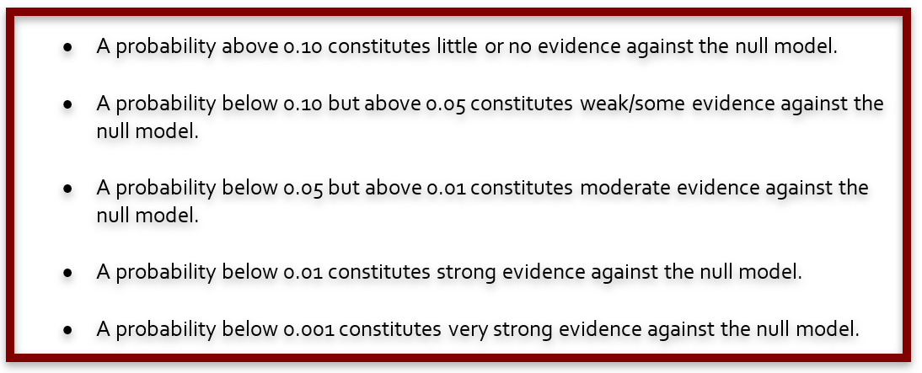
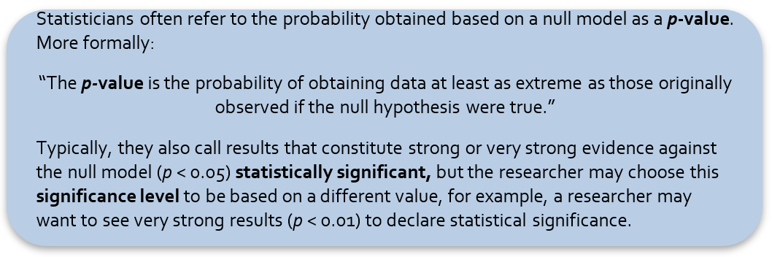

PERSPECTIVES ON DATA
- When initially creating the TinkerPlots sampler, we told you to assume that the student had no knowledge and was just guessing the notes randomly. Explain why we made this assumption and how it was relevant in determining whether Jasmine was guessing or not.

- Suppose Jasmine had only guessed 5 out of the 10 notes correctly. Would this be more evidence, less evidence, or the same degree of evidence that the student wasn’t just guessing the notes compared to the previously described situation of guessing 7 out of 10 notes correctly? Explain your reasoning.

- Now consider a note identification test in which the music teacher plays 10 notes chosen at random from 12 possible notes (A, A#, B, C, C#, D, D#, E, F, F#, G or G#). If Jasmine correctly identified 7 out of the 10 notes during this test, would this be more evidence, less evidence, or the same degree of evidence that Jasmine wasn’t just guessing the notes as identifying 7 out of 10 notes in the identification test previously described?

